SHORT BUT INTENSE KAYAK HOLIDAYS IN THE EBRO RIVER: 2 DAYS CRUISING JUNGLE AND DESERT DOWN TO ZARAGOZA.
(FLIGHTS ON FRIDAY EVENING – SUNDAY EVENING)
Description:
This 2 days trip goes along a singular branch of the Ebro river, both rich in natural values and historical patrimony. The travellers cruise the upper part of the Aragonese Ebro without interruptions, continuing the trip every morning where they finished the day before. Accommodation is held in rural B&B, and all meals (including “celebration lunch” on Sunday midday) are included in the final prize.
Starting point is Alagón, beginning of the “Cliffs branch” of the Ebro, where desert and jungle together conform a unique landscape. Ending point is the ancient city of Zaragoza, where more than 2000 years of history have yielded a vast cultural heritage and some excellent tapas bars.
Total lenght of the trip is 40 Km., with an maximum kayaking per day of 23,2 Km. Trip is intended to average fit people who enjoy outdoors activities as well as discovering singular cultural heritage (no experience needed). Single sea kayaks (Rainbow Oasis 425 or similar) and (optionally) double ones (Dagger Blackwater 13.5) will be our loyal companions.

Place: Zaragoza --> Ebro River

Duration: 3 days – 2 nights

Level: Not needed

Schedule:

- Friday:
  - 16h30 - 20h Reception of participants from airport (RyanAir flights from London, Brussels, Frankfurt…) and intermodal train station of Zaragoza.
  - 21h: Supper (traditional aragon’s Migas) and free time in Alcalá de Ebro, where the lodging will be held (rural B&B managed by ebroNAUTAS).

- Saturday
  - 9h30 – 19h Cruising down the Ebro, from La Codera to Monzalbarba. We will stop along the journey to do a trekking up the Castle of Castellar, crossing the traditional “bridge boats”, admire the cliffs of Sobradiel… and have some food and drinks from time to time.
  - 21h; Supper and guided visit to the historical centre of Alagón. Free time and transport to lodging at Alcalá de Ebro at negotiated times.

- Sunday:
  - 9-10h breakfast at the accommodation of Alcalá de Ebro.
  - 10h30 – 14h: Glorious navigated conquer of the city of Zaragoza, entering by its most beautiful door. On the way we will pass along the natural reserve of Galacho de Juslibol, as well as through the International EXPO Site in Meandro de Ranillas.
  - 14h3016h30: Final celebration meal: Guided cultural visit and Tapas tour in Zaragoza’s city center.
  - 16h30: We will transfer participants to the airport, train station, or lodging in Zaragoza (optional, although we can help you to borrow it in Zaragoza’s Hostel, a really great base from where you can continue exploring Zaragoza’s cultural and night life.

Required people: We will add individuals or groups to form a group of maximum 7 people.

It's included:
- Lodging for Friday and Saturday nights (rural B&B).
- Fully guided trips and kayak rental.
- All meals and picnics, including drinks during the kayaking.
- Insurance while you are in the river.
- Mini-van support carrying luggage.
- Maps, transfers from/to departing point each day.
- Transfer from Zaragoza airport/trainstation to first night lodging in Alcalá, and Sunday transfer to airport or lodging in Zaragoza.
- Guided cultural visits in Alcalá, Alagón and Zaragoza.
It's not included:
- Travel insurance
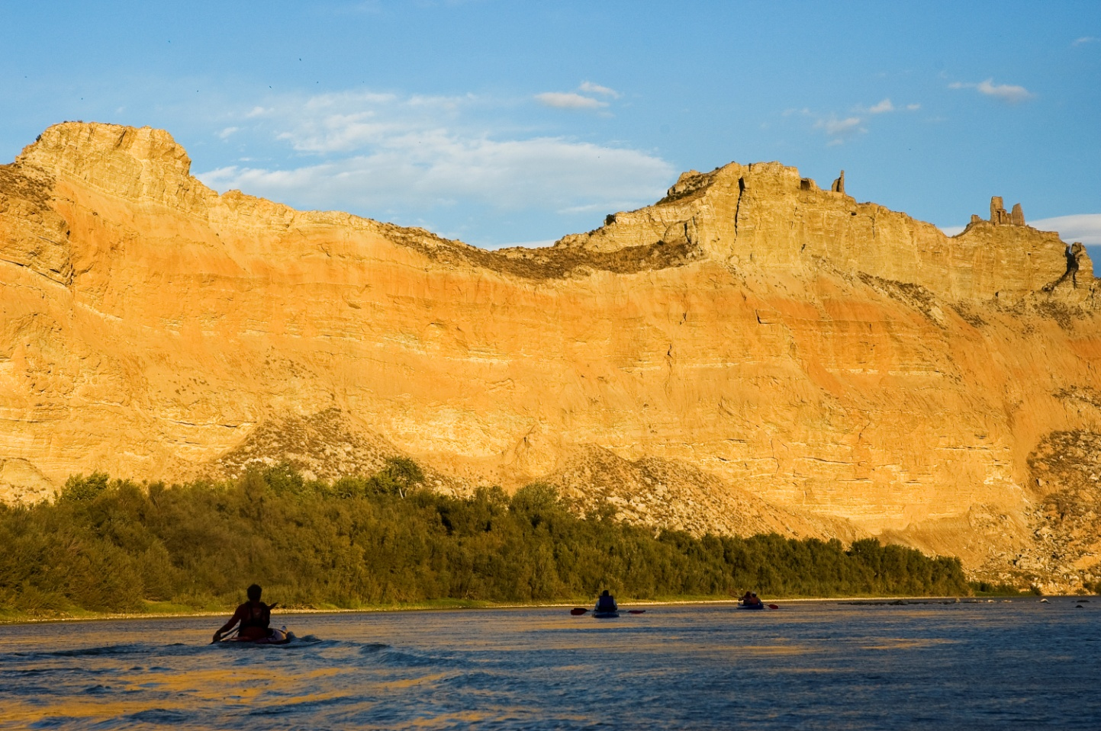
- Flights (RyanAir flights to Zaragoza from London and many other European cities)

